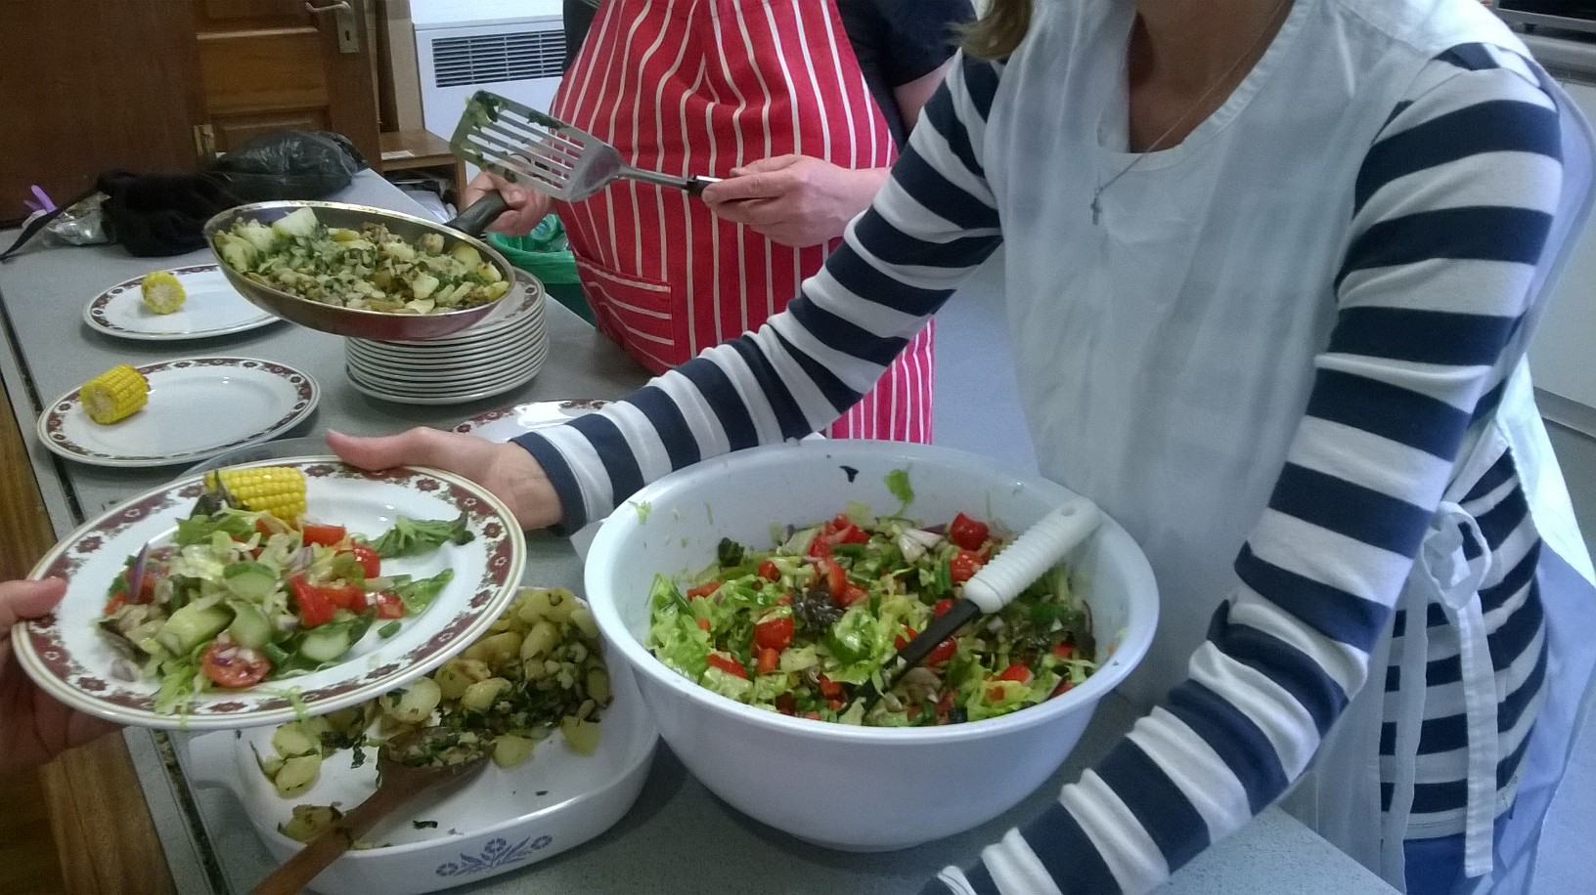  Weekly Cookery Club – starting 25 April 2019  Join us for a relaxed weekly cookery club, involving all aspects of food and cookery and the option of enjoying lunch together. We welcome everybody, with an emphasis on supporting those with mental health and social isolation issues.  When: Every Thursday 10.30am-1.30pm  Where: Upper Room, Salvation Army Bath Citadel,  Green Park Road, Bath, BA1 1XE  Cost: £4.00 (including lunch) | Gain cookery skills  ────  Boost self-esteem and confidence  ────  Progress on your mental and physical wellbeing recovery path  ────  Learn about seasonal produce and healthy eating  ────  Experience the joy of cooking and sharing delicious food  Contact Food for Thought  Tel: 01225 316 199  Mobile: 075 767 50708  e-mail: foodforthought@bathmind.org.uk

