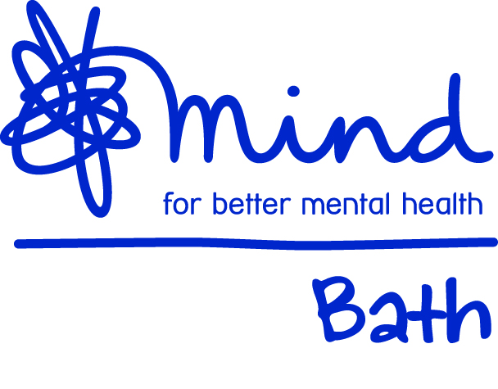

Housing Application

Please return your completed form to:
Fiona Stradling
Housing Services Manager
Bath Mind
82 Lower Oldfield Park
Bath
BA2 3HP
housing@bathmind.org.uk

Personal Details
Full name:

Name you prefer to be known as:

Date of birth:

Current address:

National Insurance number:

Contact telephone number:

Contact e-mail address:

First language:

Ethnic origin:

Sex:

Registered Disabled?

Religion:

Next of kin:
Name:

Relationship:

Address:

Telephone:

Current accommodation
Address:

Landlord:

Where have you lived during the past 5 years?
Address | Who owned it | Date you left | Reason why you left

Do you have any outstanding rent arrears at your current or previous accommodations?

Referring agency
Name of referring agency:

Address:

Telephone:
E-mail:

Contact person:

Relationship to applicant:

Is the applicant aware of this referral:

Mental health information
Clinical mental health diagnosis:

Name of Psychiatrist:

Name of Care coordinator / social worker:

Name and address of G.P:

Do you receive other types of support?

CTO? Conditions of the CTO?

Physical health conditions:

Housing Support Requirement (please tick)
24 hour support home
Minimum support home

How will this placement be funded?

Section 117 after care?

Has funding been agreed?

What level of benefits are you currently receiving and amounts?

1.

2.

3.

Do you manage your own finances?

Medication
Current medication:

Further information on medication:

Do you self-manage your medication?

Staying safe

Have you any history of drug, alcohol or solvent abuse?

Do you self harm?

Is your behaviour ever violent or abusive to others?

Are there any aspects of your current condition or risks of which Bath Mind should be aware of that could affect other tenants and the safety of the home?

Support required
Housing issues  (inc Landlord, neighbor relations, tenancy matters) |  | Claiming benefits  (Understanding benefits, claiming)
Budgeting  (Prioritizing debts, understanding bills, budget balancing) |  | Advocacy / communications  (advice and information, making complaints, seeking services)
Daily Living Activities  (basic food nutrition, hygiene etc) |  | Household managements  (general cleaning, washing, shopping etc)
Specific lifestyle choices  (Links to services) |  | Training / employment  (College, voluntary work etc)
Self help / Leisure  (use of community resources) |  | Health & Medical  (Mental health or other)
Other

Personal short and long term aspirations to work towards:
1.

2.

3.

4.

Confirmation

The information supplied on this form will be held on Bath Mind’s computers and manual records, and will be treated as strictly private and confidential. The information will only be used in accordance with the Data Protection Act 1998.The information may be used from time to time for statistical purposes.
Please check the information you have given and sign below to confirm the following statement.

I confirm to the best of my knowledge that the information in this application is true. I agree to inform Bath Mind immediately of any changes in the details given on this form. I understand that giving false information could result in cancellation of my application.

I agree to Bath Mind sharing the information given on this form with the appropriate agencies where it relates to my application.

Signature of applicant: |  | Date:

Ethnic Origin
Please tick the box which best reflects your ethnic group. Bath Mind is required to keep information on the ethnic background of all applicants and tenants. We aim to treat everyone equally, regardless of their ethnic origin, rage, colour, sex or sexual orientation.
White:
British |  | Irish |  |  | Other
Mixed:
White & Black Caribbean |  | White & Black African |  |  | White & Asian |  |  |  |  | Other
Asian or Asian British:
Indian |  | Pakistani |  |  | Bangladeshi |  |  |  |  | Other
Black or Black British:
Caribbean |  | African |  |  | Other
Chinese or other ethnic group:
Chinese |  | Other
Do not want to answer

Application for Bath Mind housing (For Bath Mind office use only)
Name of Applicant:
Date:
Housing and support applied for:
Expiry date of vacancy:
Is there a updated risk assessment and two ICPA forms attached?
B&NES CMHT referred applicant: | Yes / No
Diagnosis of mental health excluding drug/alcohol misuse. | Yes / No
Diagnosis not solely of learning difficulties: | Yes / No
Overall risk assessment: | High Medium Low
Planned acceptance into Bath Mind date:
Arranged ICPA date to discuss referral: | Date:
Written conformation to accept: | Yes / No
Reason for refusal: | - Management decision  - Support compatibility  - Risk assessment  - Relationship issues
Has the referral agent been informed? | Yes / No
Date of correspondence:
Has the applicant been informed? | Yes / No
Date of correspondence:
Has the appeals procedure been explained? | Yes / No

